Aim
To perform Data Definition Language (DDL) operations such as CREATE, ALTER, TRUNCATE, and DROP on tables in a Banking Database using MySQL Workbench.

Description
Data Definition Language (DDL) commands are used to define and manage the structure of database objects. In a Banking Database, these commands help create tables for storing customer and account details, modify existing table structures, remove all records while retaining the table structure, and permanently delete tables when they are no longer required.

Procedure
- Open MySQL Workbench and connect to the MySQL Server.
- Create or select the Banking Database using the USE command.
- Use the CREATE command to create the required banking table.
- Use the ALTER command to modify the table structure by adding, modifying, or deleting columns.
- Use the TRUNCATE command to remove all records from the table while preserving its structure.
- Use the DROP command to permanently delete the table from the database.
- Execute each command using the Execute (⚡) button or Ctrl + Shift + Enter.
- Verify the changes by refreshing the Schemas panel or using the DESCRIBE and SHOW TABLES commands.

How to Run
- Launch MySQL Workbench.
- Connect to the MySQL Server.
- Open a New SQL Tab.
- Select the Banking Database.
- Enter the required DDL command (CREATE, ALTER, TRUNCATE, or DROP).
- Execute the query by clicking the Execute (⚡) button or pressing Ctrl + Shift + Enter.
- Verify the successful execution by checking the Action Output panel and the updated database schema.

DDL Commands Covered
- CREATE – Creates new tables or other database objects.
- ALTER – Modifies the structure of existing tables.
- TRUNCATE – Removes all records from a table while retaining its structure.
- DROP – Permanently deletes a table or other database object.

QUERY 1. CREATE TABLE

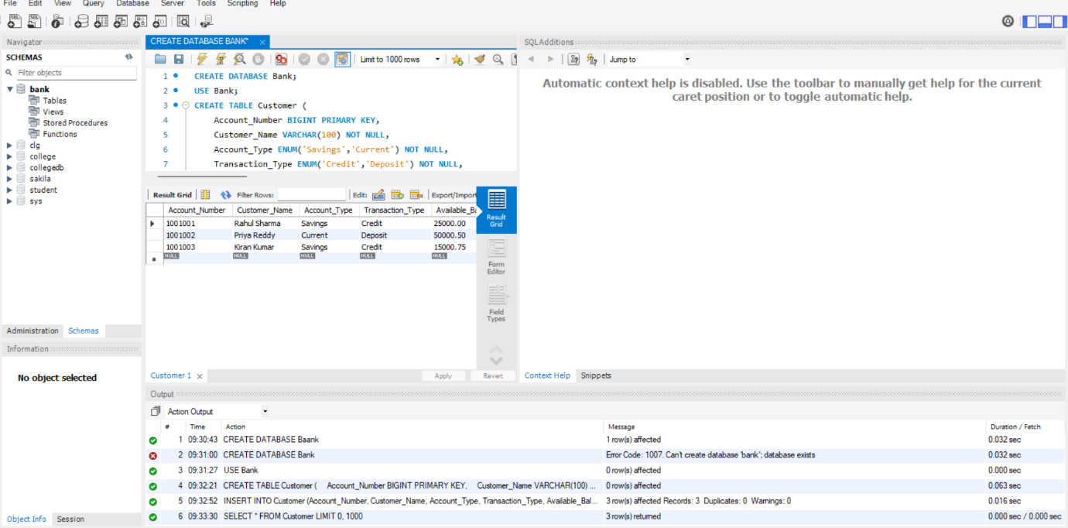

QUERY 2: DROP

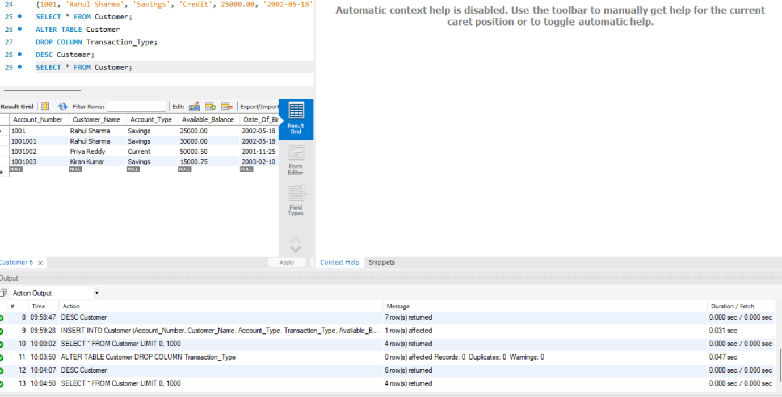

QUERY 3:ALTER

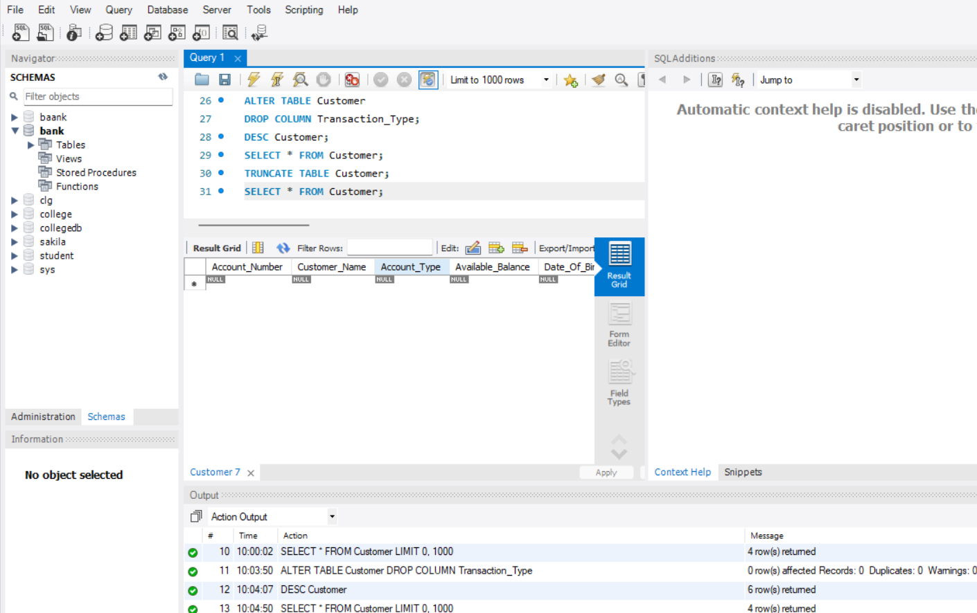

QUERY 4: TRUNCATE

